Created by: David Rubio G.
Blog: https://soceame.wordpress.com/
GitHub: https://github.com/DRubioG
Last modification date: 10/03/25

For this post we are going to base ourselves on these two previous posts.
https://soceame.wordpress.com/2025/03/09/how-to-create-a-project-for-a-smartfusion2-board/
https://soceame.wordpress.com/2025/03/10/how-to-configure-the-uart-of-a-smartfusion2/

Project in Libero
The first thing to do is to create a project in Libero, using the previous posts as a reference.
Then, we select the I2C0 to use it as an output.
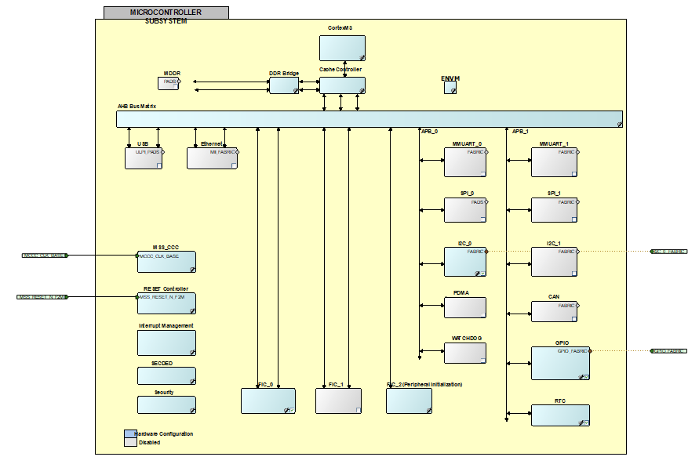
If we go into the I2C to see how it is configured, we can choose if we want to use any pin of the SoC or the specific pins for the I2C of the SoC. In our case we use any pin of the FPGA (Fabric).
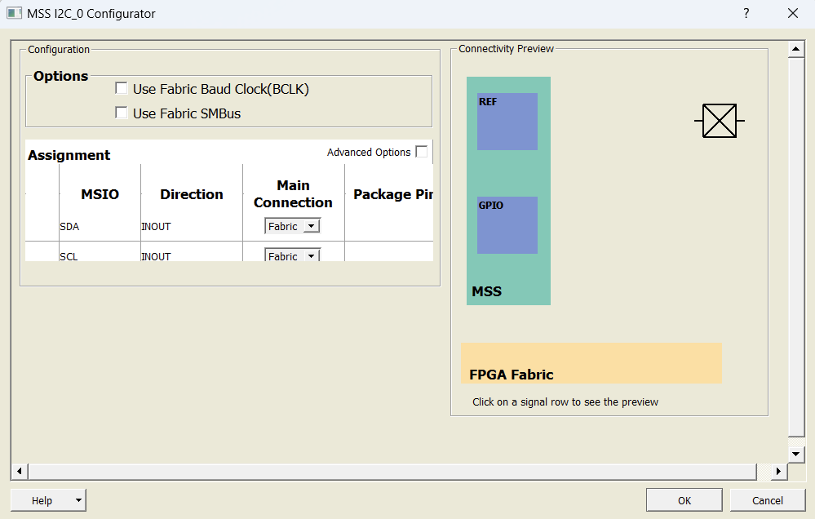
Once we have generated the I2C outputs of the core, we have to configure them. To configure the outputs, because the I2C is a bidirectional protocol, we have to use BIBUF blocks, which allow us to select the directionality of the pin with the OE output of the core. (The BIBUF block is in the Catalog)
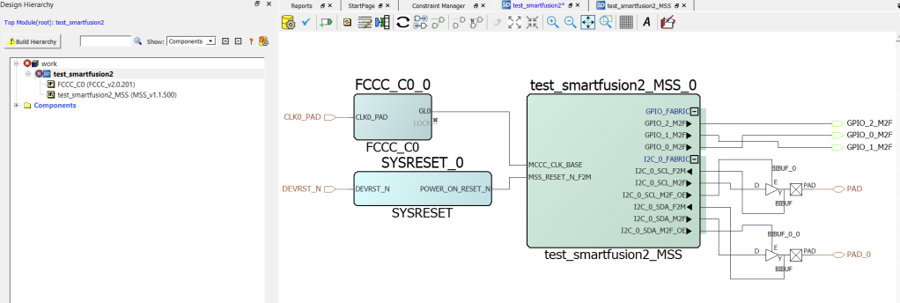
Then what we do is change the name of the pin, to do this right click on the Modify/Rename output and choose the new name.
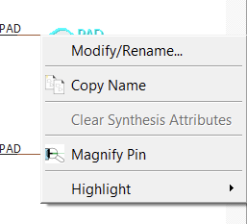
Once we have renamed the pins, it looks like this.
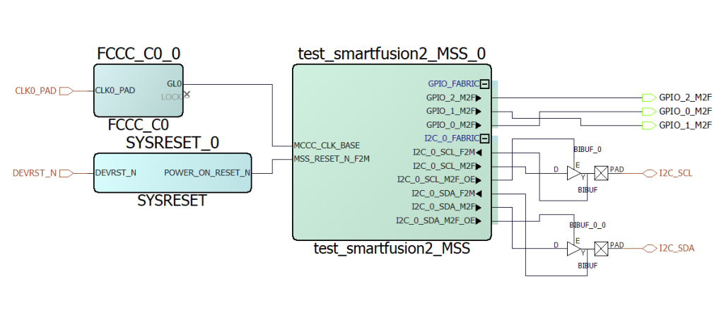
Now what we have to do is finish configuring the model, clicking on the yellow gear icon, and then on Build Hierarchy so that it adds the BIBUFs to the hierarchy. Then we synthesize the project, remember to generate the Memory Map.
After synthesizing we choose the new constraints for the pins. We open the Edit for the I/O.
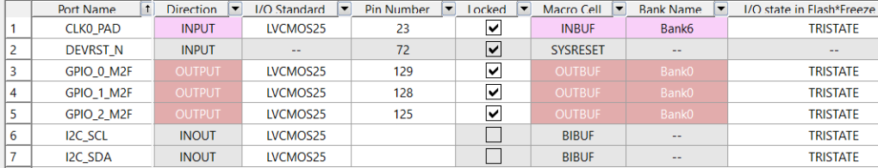
Then, we choose the I2C pins.
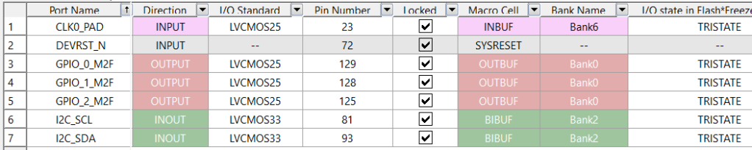
Then, we finish generating the project bitstream. When we have it, we program the SoC. And now we extract the project drivers, to do this we click on Configure Firmware Cores.
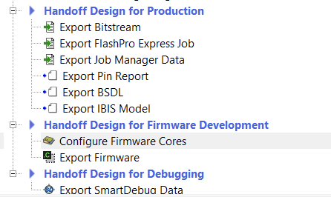
We have to have the I2C drivers selected.
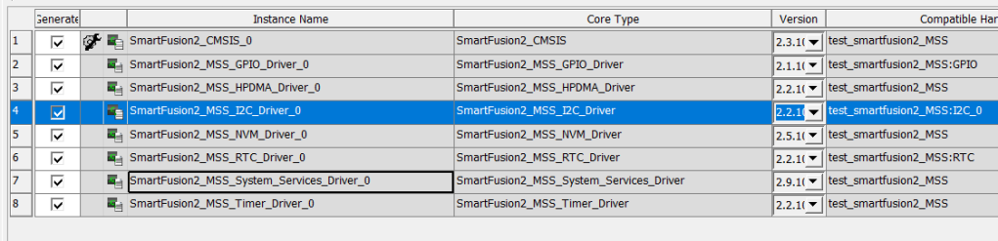
Then we export them.
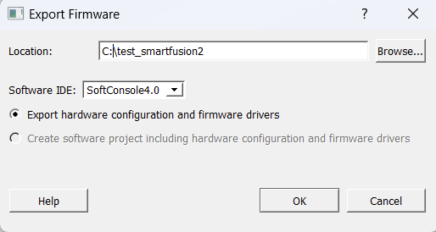

Project in SoftConsole
The first thing we do is create an empty C project
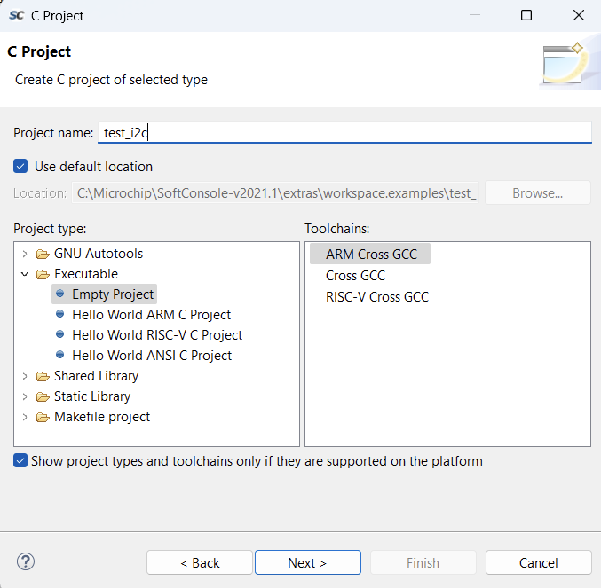
When the project is created, we have the folder with the includes.
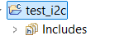
Now we add the drivers that we just exported and create a main.c file.
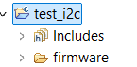
Now we have two options for creating the I2C, either as a master or as a slave.
- master
If we define it as a master, the first thing we have to do is configure the I2C as a master (MSS_I2C_init) and then tell it to write (MSS_I2C_write) the data that is in the write buffer (tx_buffer). There is also a buffer that is the write buffer that the slaves use to send data to the master.
NOTE: it is important to understand that the master of a communication has to tell the slaves when it is going to read, how much data it wants to read, in this example 16 data.
#include "firmware/drivers/mss_i2c/mss_i2c.h"

#define I2C_DUMMY_ADDR 0x10u
#define DATA_LENGTH 16u

uint8_t tx_buffer[DATA_LENGTH];
uint8_t write_length = DATA_LENGTH;

void main(){
uint8_t target_slave_addr = 0x12;
mss_i2c_status_t status;

// Initialize MSS I2C peripheral
MSS_I2C_init( &g_mss_i2c0, I2C_DUMMY_ADDR, MSS_I2C_PCLK_DIV_256 );

// Write data to slave.
MSS_I2C_write( &g_mss_i2c0, target_slave_addr, tx_buffer, write_length,
MSS_I2C_RELEASE_BUS );

// Wait for completion and record the outcome
status = MSS_I2C_wait_complete( &g_mss_i2c0, MSS_I2C_NO_TIMEOUT );

}
- slave
As a slave, it is necessary to understand that the slave of an I2C communication is totally reactive, that is, it will not emit data for its own interest, but rather it has to be the master that requests the data.
The I2C of the SmartFusion2 is composed of two buffers, one for reading, which is the one that the master reads when it sends the reading order, and one for writing, which is the one that the master uses to communicate with the slave.
In addition, as the I2C is configured in the SmartFusion2, an interruption is not generated when new data arrives, so the only way to know if data has arrived is by reading the writing buffer on a recurring basis.
#include "firmware/drivers/mss_i2c/mss_i2c.h"

#define SLAVE_SER_ADDR 0x10u
#define SLAVE_TX_BUFFER_SIZE 10u
#define SLAVE_RX_BUFFER_SIZE 10u

uint8_t g_slave_tx_buffer[SLAVE_TX_BUFFER_SIZE] = { 1, 2, 3, 4, 5,
6, 7, 8, 9, 10 };
uint8_t g_slave_rx_buffer[SLAVE_RX_BUFFER_SIZE];

void main( void )
{
// Initialize the MSS I2C driver with its I2C serial address and serial
// clock divider.
MSS_I2C_init( &g_mss_i2c0, SLAVE_SER_ADDR, MSS_I2C_PCLK_DIV_256 );

MSS_I2C_set_slave_tx_buffer( &g_mss_i2c0, g_slave_tx_buffer,
sizeof(g_slave_tx_buffer) );

MSS_I2C_set_slave_rx_buffer( &g_mss_i2c0, g_slave_rx_buffer,
sizeof(g_slave_rx_buffer) );

MSS_I2C_enable_slave( &g_mss_i2c0 );
}
If you try to compile the project it will fail, because you have to configure the compiler directives that SoftConsole needs, and they are always the same.
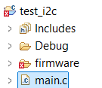
These compilation directives are defined in the previous entries.

